**MODERN APPLICATION DEVELOPMENT USING JAVA SPRING BOOT**

**ASSIGNMENT-3**

**NAME: SHARAN KRISHNA**

**REG NO: 20BCE1670**

**CAMPUS: CHENNAI CAMPUS**

**QUESTION:**

**IMPLEMENT JDBC CONNECTIVITY USING JAVA**

**STEPS:**

To implement JDBC (Java Database Connectivity) connectivity using Java, you need to follow these steps:

1. Set up the database: Install and configure the database you want to connect to. Ensure that you have the necessary credentials (such as username and password) to access the database.

2. Load the JDBC driver: JDBC drivers are typically provided by database vendors. You need to load the appropriate driver class before establishing a connection. The driver class name varies depending on the database you are using. For example, for MySQL, you would use `com.mysql.cj.jdbc.Driver`.

3. Establish a connection: Use the driver manager to establish a connection to the database. You need to provide the database URL, username, and password for authentication.

4. Execute SQL statements: Once the connection is established, you can execute SQL statements like select, insert, update, delete, etc. You can use `Statement`, `PreparedStatement`, or `CallableStatement` interfaces to execute the queries.

5. Process the result: Retrieve and process the result returned by the executed SQL statements. You can use methods like `executeQuery()` for select statements and `executeUpdate()` for update statements to retrieve the result.

6. Close the connection: After executing the necessary queries, make sure to close the connection and release any resources associated with it. This step is crucial to free up system resources and maintain good performance.

**CODE:**

package jdbcdemo;

import java.sql.*;

public class jdbcExample {

public static void main(String[] args) {

String url = "jdbc:mysql://localhost:3306/jdbcdemo";

String username = "root";

String password = "";

try {

// Load the JDBC driver

Class.*forName*("com.mysql.cj.jdbc.Driver");

// Establish the connection

Connection connection = DriverManager.*getConnection*(url, username, password);

// Create a statement

Statement statement = connection.createStatement();

// Execute a query

String query = "SELECT * FROM student";

ResultSet resultSet = statement.executeQuery(query);

// Process the result

while (resultSet.next()) {

int id = resultSet.getInt("id");

String name = resultSet.getString("name");

int age = resultSet.getInt("age");

// Process the retrieved data as per your requirement

System.***out***.println("ID: " + id + ", Name: " + name + ", Age:" + age);

}

// Close the connection and release resources

resultSet.close();

statement.close();

connection.close();

} catch (Exception e) {

e.printStackTrace();

}

}

}

**DATABASE:**

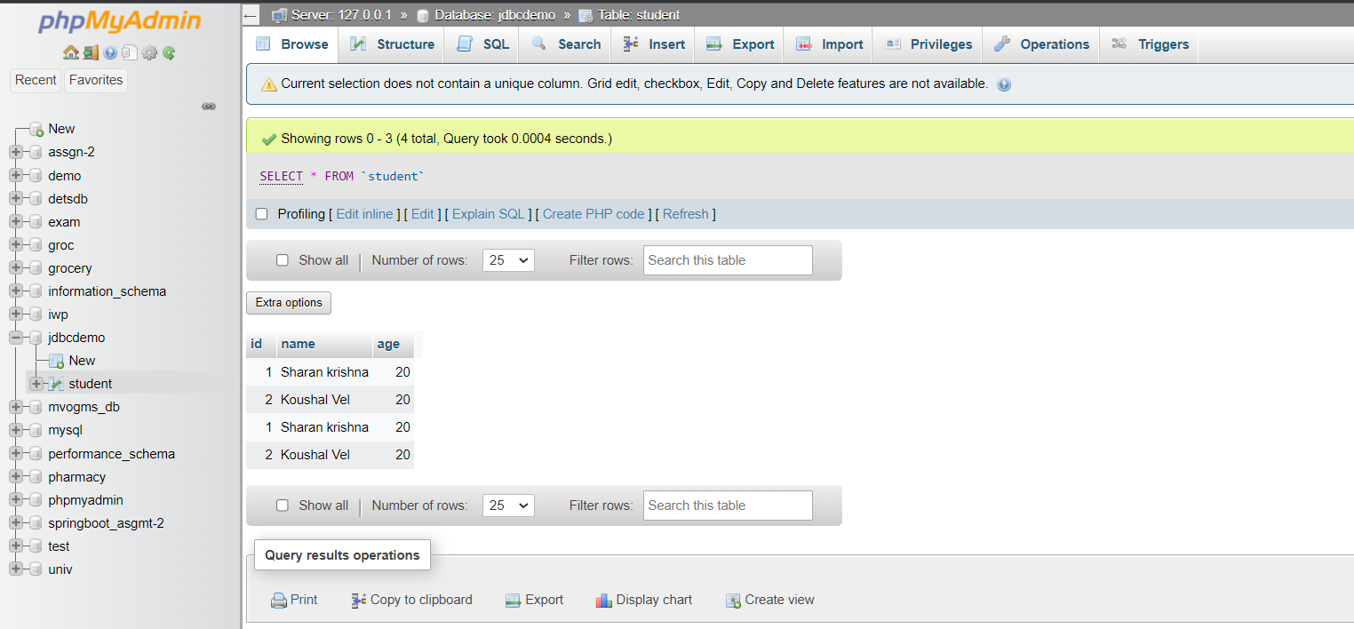

**OUTPUT:**

